Ice Cream

Subject: Chemistry, Freezing Point  Related Subjects: | Grade Level(s): 4 & 5  Length of Lesson: 71 minutes | Type: Inquiry / Design / Project  Keywords: Freezing Point, heat transfer, states of matter, conduction

Lesson Overview
With the addition of salt, the freezing point of water is lowered, making it colder. Heat is drawn out from the milk by the salt and ice mixture, making it colder and until it solidifies.

Lesson Focus
Students will make ice cream using household items such as plastic bags, ice, salt, and milk while learning about the process of heat transfer.

Lesson Objective(s) | - The student will learn about the process of heat transfer through conduction.

Lesson Timing

Time [min] | Description
5 | Introduce the Lesson  - End Goal  - Primer Questions  - Key Vocab Words
1 | Role Models in STEM
Engineering Method
5 | Real World Example
5 | Hypothesis & Prediction
5 | Brainstorm & Design
20 | Build & Create
10 | Test & Record
5 | Assess & Evaluate
5 | How to improve?
10 | Lesson Cleanup

Materials | - 2 Gallons of milk  - Sugar  - Vanilla flavoring  - 8-10 Gallons of Ice  - 30 Spoons  - 30 Cups  - Paper towels  - 1 Gallon Ziploc bags (30)  - 1 quart Ziploc bags (30)  - Rock Salt
Instructor Prep | - Step 1
Related Resources | - List related lessons/ppts etc available from USC or outside, trusted orgs

Lesson Plan

Introduction
- What are some everyday examples of heat transfer?
  - The handle of a spoon sitting in tea will get hot.
  - Opening the window when the heat or AC is on will change the temperature of the house.
- What is the difference between conduction and convection?
  - Conduction involves direct contact.
  - Convection involves the circular flow of heat usually through air or water.

Procedure
- Cover table with paper towels.
- Open milk container and pour into 1 quart Ziploc bag.
- Add 2 teaspoons of sugar and 1 teaspoon of vanilla flavoring to milk.
- Seal the bag and shake the bag for about 1 minute.
- Put the smaller bag inside the large Ziploc bag.
- Add enough ice to cover the small bag and add a cup of salt.
- Seal the large bag.
- Flip the bag over and over (by holding corners) on the paper towel.
- After 10 minutes take temperature of the ice cream.
- Keep flipping until you get ice cream!
- Once you get ice cream, take the smaller bag out of larger bag.
- Pour the contents of the larger bag into a sink
- Dish out the ice cream into a cup and enjoy.

Wrap-up
The purpose of the survey is to let us know your opinions about today’s project. Remember there are no right or wrong answers.

 |  | Strongly Disagree | Disagree | Undecided | Agree | Strongly Agree
1 | The project increased my interest in science
2 | After this project, I am more confident in doing science

3. What does a food scientist do?

4. How does heat transfer work?

5. In your own words, what were the procedures (or steps you took) to make ice cream?

Lesson Background for Teachers

Real World Example
- Where in the real world does the main principle for this lesson apply?
- How have engineers/scientists used this principle?

Hypothesis & Prediction
- How would changing the amounts of salt, ice, or milk affect the final product?

Brainstorm & Design
- How may the use of a machine like an ice cream churner facilitate the process?
- How would the challenge of making a larger amount of ice cream be approached?

Build & Create
- Students will make ice cream using household items and ingredients.

Test & Record
- Students can see how factors such as time and motion will affect the texture of their ice cream.

Assess & Evaluate
- Students can assess the effectiveness of using various amounts of ice or salt, or how the amount of time spent shaking the ice cream could affect the texture and solidity.

How to Improve?
- Different ratios of products
- Different flavors
- Different methods such as the utilization of machinery

Lesson Variations and Options
Include descriptions of alternative methods or ways to present things.

Explanation
As heat is removed from water, the molecules slow down. At the freezing point, the motion of the molecules is slow enough that the water solidifies and becomes ice.

When you add salt to water, the salt and water molecules stick together. Heat then must be removed to slow down and separate the combined salt and water molecules. The removal of the additional heat is required to freeze the salt-water combination, lowering the freezing point. As you mix the salt and ice, it gets colder than the milk. Since heat travels from warmer to colder, heat is drawn from the milk, making it colder and more solid.

Key Concepts and Vocabulary
- Matter
  - What makes up everything around us.
- Freezing Point
  - The temperature at which a substance becomes cold enough to solidify.
- Conduction
  - The transfer of energy through direct contact.
- Heat Transfer
  - Movement of thermal energy (heat) from one thing to another.
- Convection
  - Circular motion of heat due to the rising and falling of temperatures.

Safety Notes
- Safety instruction

Role Model in STEM

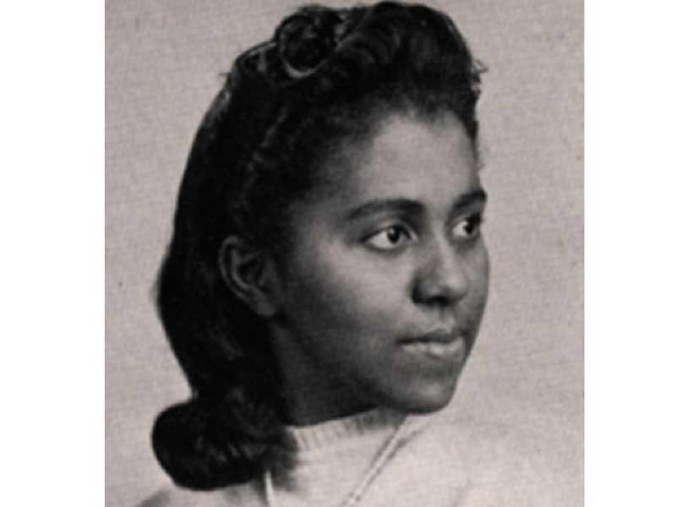
Name: Marie Maynard Daly
Years: 1921-2003
Quick Facts
- First African American Woman to earn a Ph.D. in chemistry (Colombia University, 1947)
- Biochemist
- Studied cell/organelle functions
- Studied the effects of aging, hypertension, and atherosclerosis on the heart
- Recognized as one of the top 50 Women in Science, Engineering, and Technology by the National Technical Association

